LA-IMPERIAL



**Group Members:**

* **M.Areeb Siddique** Student1397595
* **Shayan Ahmed Siddique** Student1399708
* **Aashir Aamir Baig** Student1398617

**Faculty Data:**

* **Faculty Name :** Amir Hamza
* **Coordinator Name :** Iqra Khan
* **Center Name :** Aptech NN

**USER GUIDE**

**HOME PAGE**

**In homepage we have our company’s logo , a navbar ,description of our company,**

**A navbar, product cards , about the founder and the achievments of our company**

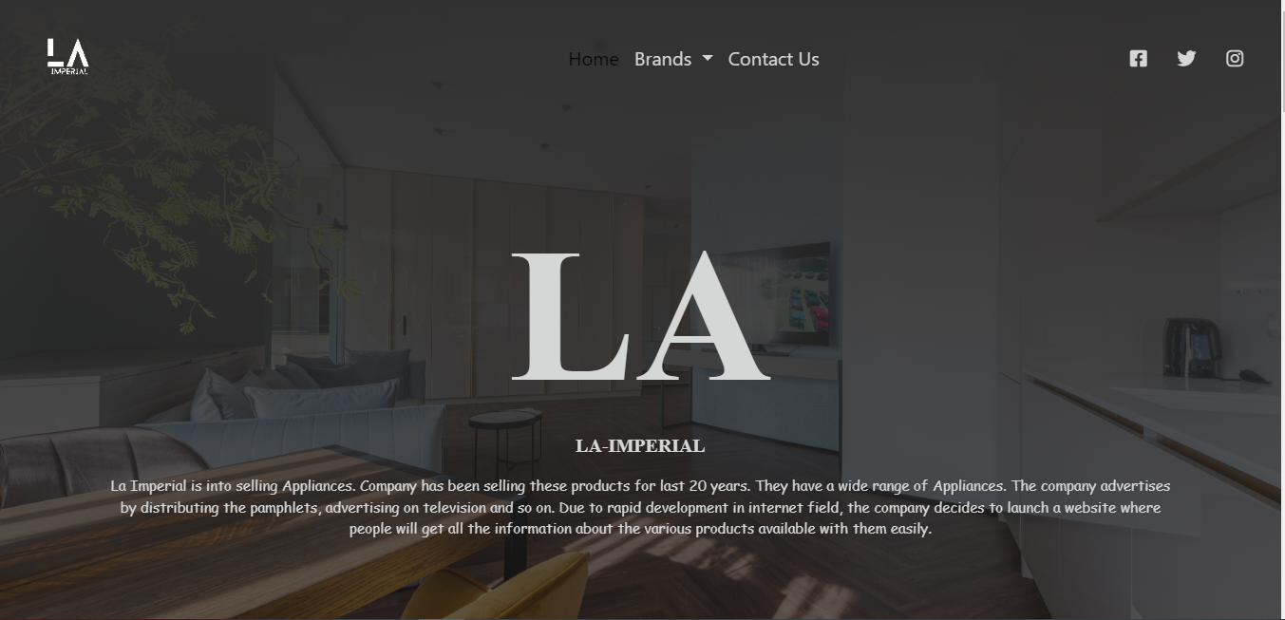

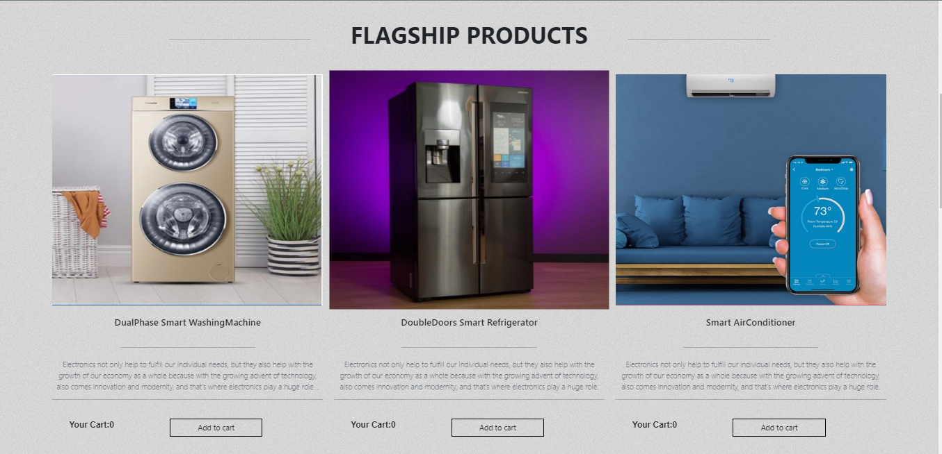

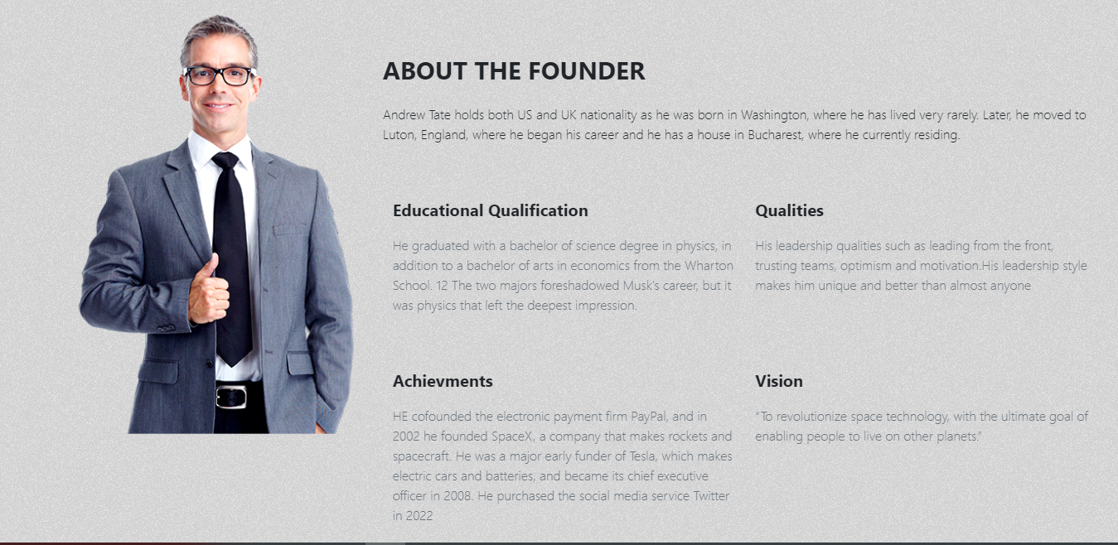

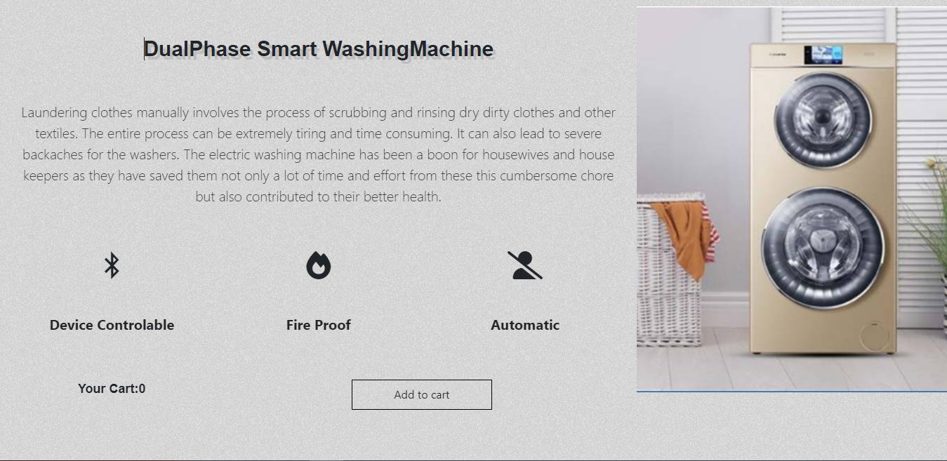

**CONTACT US**

In contact us page there’s a form to chat with us there’s detailed guidance for our location and a map and our contact information.

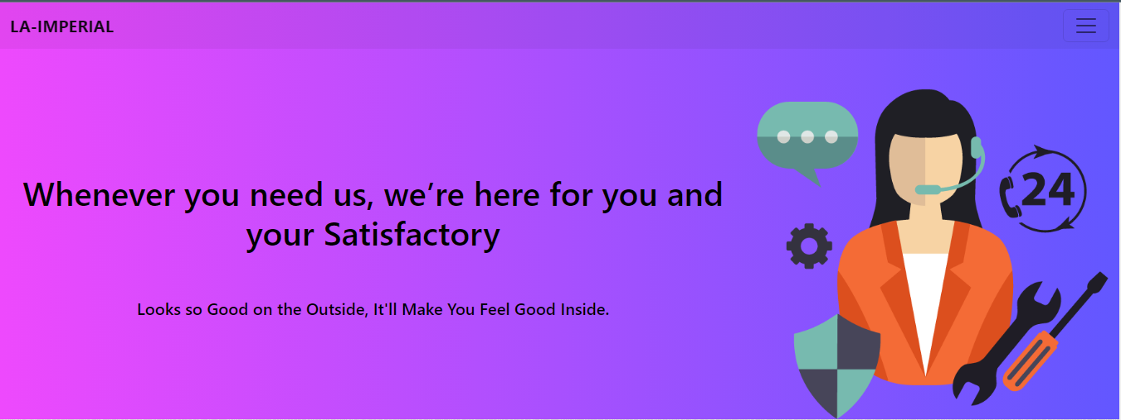

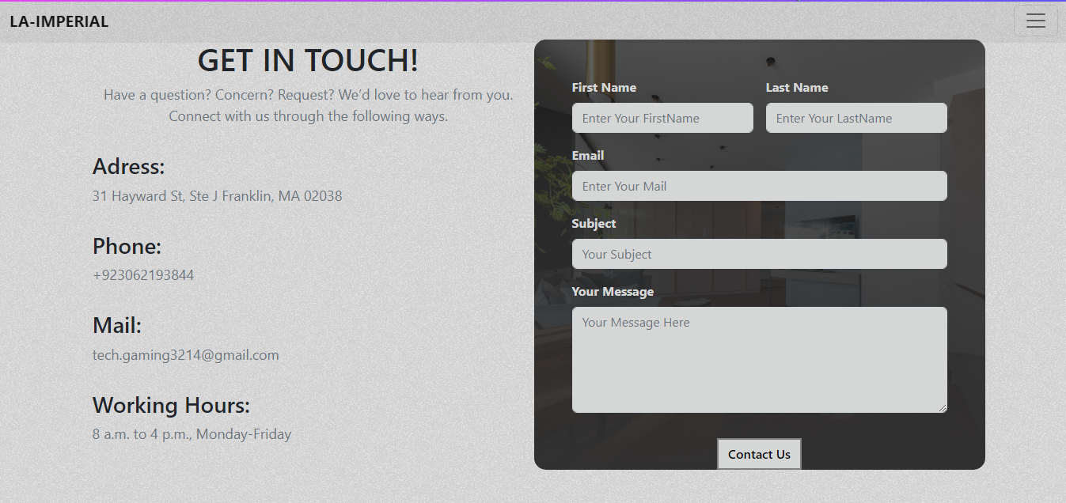

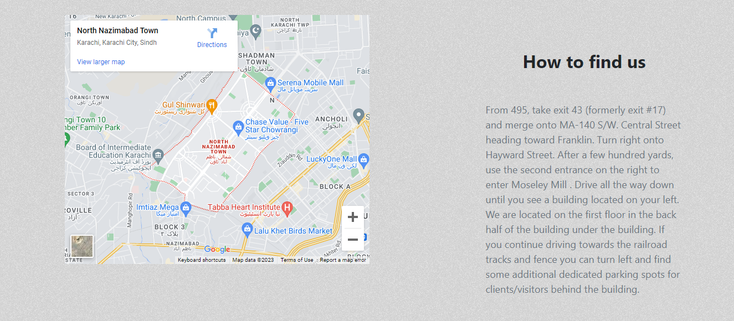

BRANDS (HAIER)

This page contains navbar logo and categories for product.

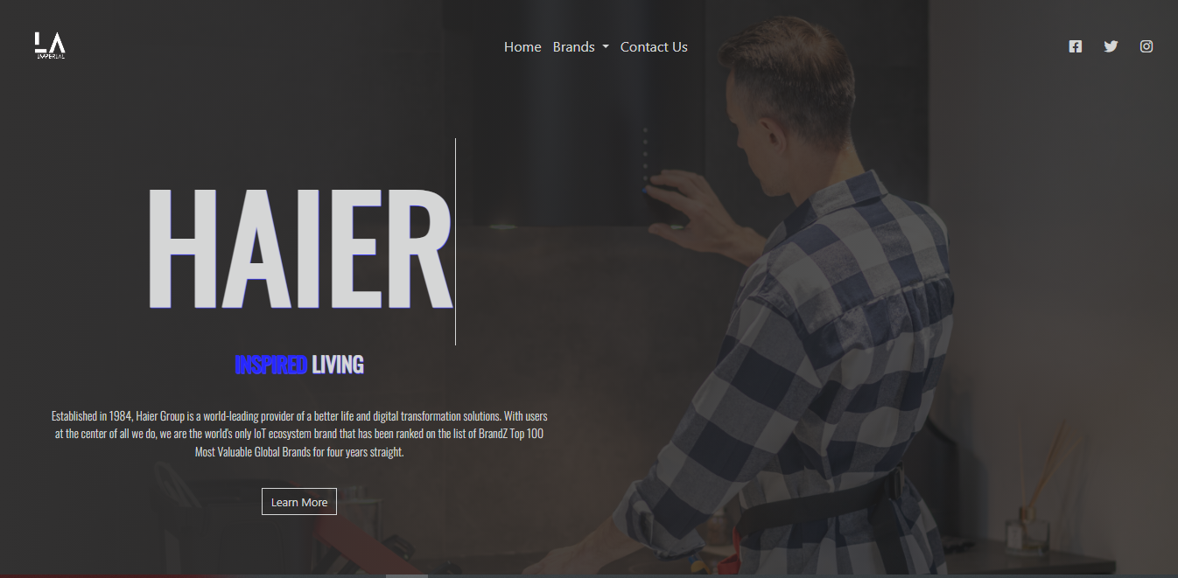

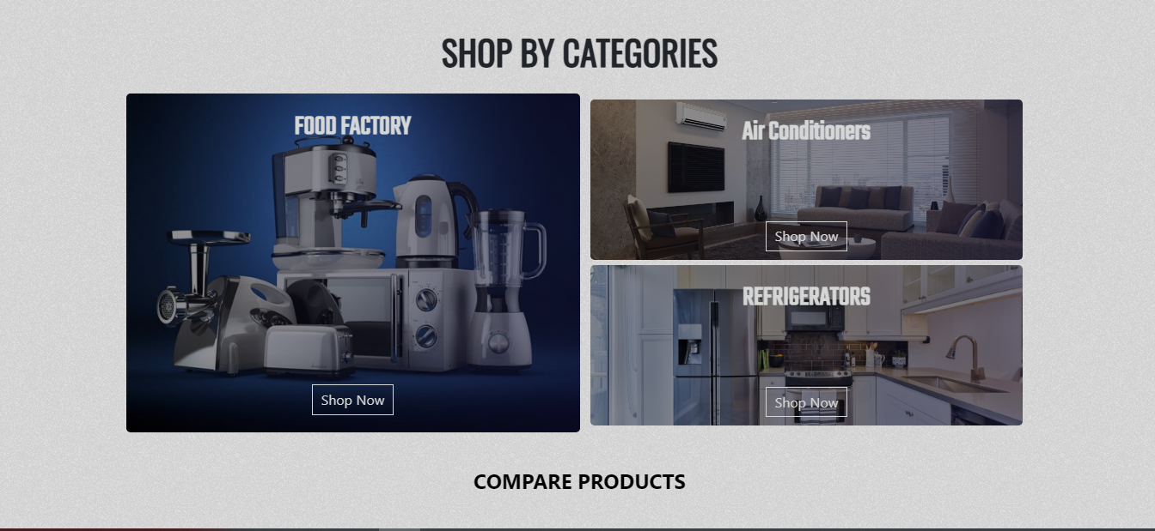

BRAND(DAWLANCE)

This page contains navbar logo and categories for product.

